**Name: Sydia Tamanna**

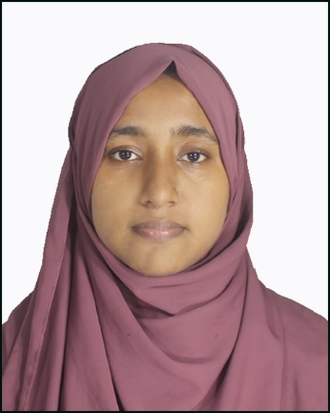

**Phone number**: 01315398081

**Email:** syidatamanna@gmail.com

**Address:** Barishal University, Barisal.

**PERSONAL INFORMATION**

**Date of Birth:** 09/10/2002

**Marital Status**: Unmarried

**Religion:** Islam

**Nationality:** Bangladeshi

**OBJECTIVE**

To secure the position of coaching instructor, where I can utilize my expertise in (Bangla, English, Math,) with my strong communication skills, innovative teaching techniques, and dedication to fostering student success. I aim to inspire a love for learning and help students achieve their academic and personal potential.

**EDUCATION**

|  |  |  |  |
| --- | --- | --- | --- |
| DEGREE | GPA | BOARD | YEAR |
| SSC | 4.82 | DHAKA | 2019 |
| HSC | 5.00 | DHAKA | 2021 |

**Current Institution: Department Of Economics, University Of Barishal**

|  |  |
| --- | --- |
| **SKILL** | **LANGUAGE** |
| •Problem Solving  •Communication skill  •Hard worker  •Leadership | •Bangla  •English |

**Reference: Rezaul Karim ,Faculty of English and Career map Coaching center.**